# Support Bot Snippets

Provide Info

Thanks for reaching out to [Bob.ai](http://bob.ai/) support, I'm happy to help!

Please provide me with the following info:

1. The name of the housing agency you are signed up under?

2. The name on your voucher

3. The unit address

4. Also, did you create your [Bob.ai](http://bob.ai/) account using the email address that is on your voucher?

Awaiting your response.

Georgia Simpson

Business Development Manager

[Bob.ai](http://bob.ai/) Inc

[www.bob.ai](http://trail.bob.ai/api/t/c/usr_eYy79TtH6qzDK9hFM/tsk_HQxjbszGCDpMYW9dE/enc_U2FsdGVkX18Zda9hN-__BBoyI7LUMTb6XM9TOrWqy8Ko9g-gL_ruzeeSHKnR74W-Pn6Z2Z44P1Mg0VU-OPjc239Byzl7ZW6uH_ag2aDZJ9aVwN8wzlWTgi0LfHlGCMsuVrRCoc5jzRdMbHnxd5MtDxeFoYSNuBiy42eufzKf8hE=)

Survey Link

<https://docs.google.com/forms/d/e/1FAIpQLScMRyVpXPUAHumyLFMB6vQz6oCNoRmttYLHMtlOMFVRgnfhbA/viewform?usp=sf_link>

We are working on implementing a new service just for landlords and we would really appreciate your input. If you wouldn't mind too much, please complete this quick survey, it shouldn't take more than 5-10 minutes I promise.

[Concierge Services Survey Form](https://docs.google.com/forms/d/e/1FAIpQLScMRyVpXPUAHumyLFMB6vQz6oCNoRmttYLHMtlOMFVRgnfhbA/viewform?usp=sf_link)

Thanks so much!

***********************************************************************************************************

I'm happy to help so that I can best assist you, kindly reply with a screenshot of the issue you are experiencing.

<https://dhantx.com/wp-content/uploads/2021/10/Allowance-Apt-Condo-Townhouse-10.01.2021.pdf> (Apt/Townhouse/Condo)

<https://dhantx.com/wp-content/uploads/2021/10/Allowance-single-family-duplex-10.01.2021.pdf> (Single family/Duplex)

<https://bob.ai/pha/texas/dallas-housing-authority> (Affordability Calculator)

A Relationship code has been emailed to you, kindly retrieve the code and then go to My Account>>Enter Relationship Code on your Bob.ai app

I hope this helps.

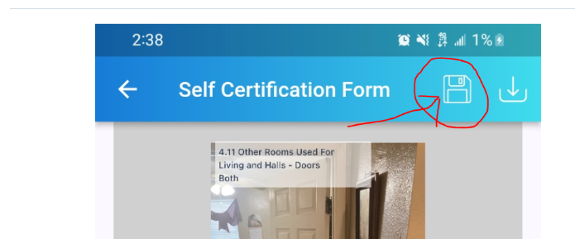

Hello Kimberly

Thanks for letting me know, I've sent you an invitation to link your [Bob.ai](http://bob.ai/) account to the units. Kindly go to My Account from a computer to accept it. Then please check for your units under Inspections and let me know if you still need help.

# Update your Renter Profile

Hello

Your voucher is already uploaded to your account, you should be able to see it under Vouchers and Referrals.

To update your Renter Profile:

1. Log into your [Bob.ai](http://bob.ai/) account from a computer/laptop

2. Click on Vouchers and Referrals

3. Click the three dots beside your voucher to get to Virtual Voucher Briefing or to update your Renter Profile

Here is also a video to help you <https://www.youtube.com/watch?v=dxYE6_4sQPU>

You may also find useful guides and FAQs under the Community tab on your [Bob.ai](http://bob.ai/) account.

Best regards

Hello

I'm happy to help, I have added links to two videos that should be helpful with updating your renter profile and calculating your affordability.

You may visit Community on your [Bob.ai](http://bob.ai/) account to get quick answers on our FAQ pages and to access video guides for navigating the platform.

[Updating your Renter Profile](https://youtu.be/dxYE6_4sQPU)

[Check Affordability on your Renter Profile](https://youtu.be/in40oykgq0c)

[How to sign your Voucher](https://www.loom.com/share/94f830b9e56642b09939ed547aa65226)

[How to sign RFTA from the Bob.ai mobile app](https://www.youtube.com/shorts/Cxa9P8riWNg)

I hope this helps.

Relocation/ Processing time   
  
Hello

The Good Standing letter has been emailed to your current landlord. They will have 15 days to complete this in Bob.ai. If they do not return it within this timeframe, your relocation request will be submitted for approval.

DHA case managers approve relocation requests within 7-14 days after the letter is received. Once the relocation request is approved, the voucher is issued by email within 1-2 business days and will show up on your Bob.ai account under Vouchers, 24-48hours after issuance.

Kindly ask your landlord to sign and return the letter to speed up your processing time.

I hope this helps.

*******************************************************************************************************

Your Relocation Request is pending the receipt of the Good Standing Letter from your current landlord.

Once the letter is received, DHA case managers will approve it within 7-14 days. However, If it has not been received within 15 days calendar, your request will be reviewed for approval.

Once it is approved, the voucher will be issued and you'll be sent an email with your voucher info.

Kindly ask your landlord to sign and return the letter to speed up your processing time.

I hope this helps.

Please note that if the letter is not signed and returned by 1 March 2024, the Housing Authority will automatically deem you to be in good standing with the Lease Agreement. Then once your relocation request is approved, the voucher will be issued and you'll be sent an email with your voucher info.

I hope this helps.

Failure to provide this notice to the Housing Authority within fifteen (15) calendar days from the date of this email will result in the Housing Authority deeming the Tenant is in good standing with the Lease Agreement.

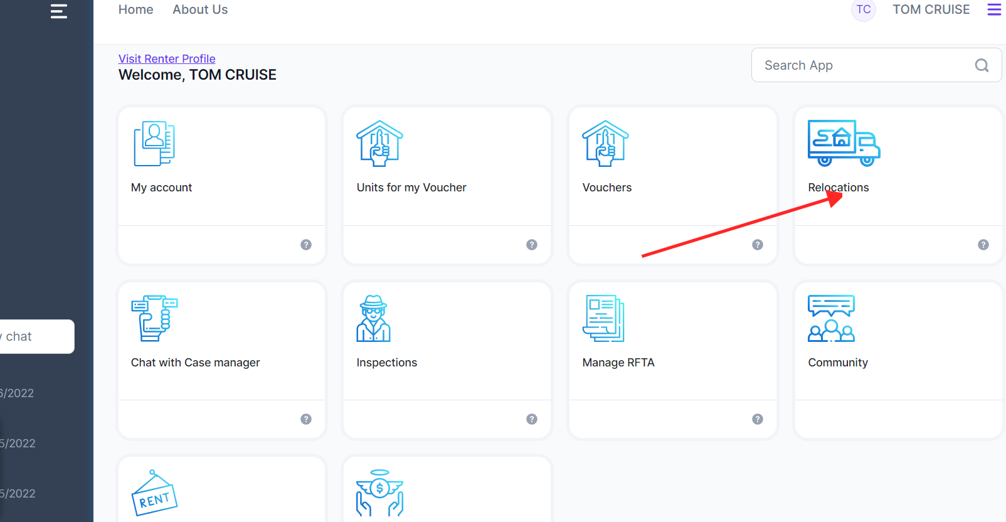

Locate/Sign Voucher

Thanks for contacting Bob.ai support, we appreciate your patience as we work to improve our response time.

Once you have set up your account correctly as a renter, you should be able to locate your voucher under the Vouchers tab on your Bob.ai account.

From here, you should be able to update your renter profile as well as view and sign your voucher.

When you have updated your voucher, you can search for a unit under Units for my Voucher and Explore Rentals, as well as outside of Bob.ai

Once you have found a unit, the landlord will need to create an RFTA on Bob.ai for you. When the RFTA is complete, you can locate it under the Manage RFTA tab. You will then be able to upload any required documents, attach your signature and submit the RFTA to the DHA's relocation team for review.

Here are some videos you may find helpful:

[Updating your Renter Profile](https://youtu.be/dxYE6_4sQPU)

[How to sign your Voucher](https://www.loom.com/share/94f830b9e56642b09939ed547aa65226)

[Check Affordability on your Renter Profile](https://youtu.be/in40oykgq0c)

[How to Share your Renter Profile on Bob ai Mobile App](https://www.youtube.com/watch?v=U6N_HWMDNVs)

[Printing a Voucher (as a logged in Renter)](https://www.youtube.com/watch?v=jpWh1rA_kHc)

[Sign RFTA on Mobile & Upload Notice to Vacate](https://www.youtube.com/watch?v=uU3s1eCU8MQ)

I hope this helps.

RFTA landlord

Thanks for contacting [Bob.ai](http://bob.ai/) support, I'm happy to help!

If you are a renter,

I hope this helps, however, if you have more concerns or questions please reply to this email.

***********************************************************************************************************

Hello

Thanks for contacting Bob.ai support, I'm happy to help! Your landlord will need to create an account on [Bob.ai](http://bob.ai/) to start the RFTA for you. They will then fill in all the information about the unit, sign it, and send it to you, the status will then change to “Sent to Client”.

Once the RFTA has been sent, you can find it in the Manage RFTA app. Then you will be able to upload any necessary documents and attach your signature. You will then sign and submit the RFTA to the PHA for processing; once the RFTA is approved, an inspection will be scheduled.

The Housing Authority typically processes RFTAs within 3-7 business days. Once approved, the unit will be inspected, and you will be notified. You will then be able to view and track your inspection on Bob.ai under the Inspections tab.

You may share this video guide with the landlord: [e-RFTAGuide](https://www.youtube.com/watch?v=-sHvBl4RCcg&t=6s) as well as visit [Bob.ai-Youtube](https://www.youtube.com/@Bobai-im5nr) for other helpful guides.

I hope this helps, however, if you have more concerns or questions please reply to this email.

********************************************************************************************

If you are a renter, your landlord will need to create an account on Bob.ai to start the RFTA for you. They will then fill in all the information about the unit, sign it, and send it to you, the status will then change to “Sent to Client”.

Once the RFTA is sent, you can locate it under the Manage RFTA app. Then you will be able to upload any required documents, attach your signature and submit the RFTA to your housing agency for processing.

I hope this helps, however, if you have more concerns or questions please reply to this email.

********************************************************************************************

Once you have found a suitable unit, the landlord will need to create an RFTA for you on Bob.ai.

They will then fill in all the information about the unit, sign it, and send it to you, and the status will change to “Sent to Client”.

Once the RFTA is sent, you can locate it under the Manage RFTA app. Then you will be able to upload your Notice to Vacate under the Additional Document section of the RFTA packet, and then sign and submit the RFTA to the DHA for processing.

RFTAs are processed by the Housing authority within a typical time frame of 1-7 business days. Once approved an inspection will be scheduled for the unit and you will be notified. You then will be able to view and track your inspection under the Inspections tab on Bob.ai.

You may share this video guide with the landlord: [e-RFTAGuide](https://www.youtube.com/watch?v=-sHvBl4RCcg&t=6s) as well as visit [Bob.ai-Youtube](https://www.youtube.com/@Bobai-im5nr) for other helpful guides.

I hope this helps, however, if you have more concerns or questions please reply to this email.

Draft

Your RFTA is incomplete and is still in "Draft" status, the landlord will need to complete and submit the RFTA so that you can sign it. You will not be allowed to sign the RFTA until the landlord completes their process.

Once the landlord completes their portion, the status will change to "Sent to Client" and you will receive an email to sign the RFTA online.

I hope this helps.

Not involved

I'm extremely sorry to hear about this situation, however, as previously advised, we are not involved with that part of the process, you will need to reach out to your housing agency directly at 469-249-9012, 12149518300 Monday - Thursday: 8 am - 5:30 pm and Friday: 8 am - 12 pm or send them an email at contact@dhantx.com.

**********************************************************************************

Thanks for reaching out to [Bob.ai](http://bob.ai/), however, we are not involved with that part of the process, you will need to contact your housing agency directly.

You may also use the Chat with a Case Worker on feature on Bob.ai. to create a case.

A case worker from your housing agency will be assigned to assist you with your concern. Response time is typically 2-3 business days.

Best regards

*******************************************************************************************

I'm sorry to learn about the situation you are currently experiencing, however, as we are not involved with that part of the process, it would be best to contact your housing agency directly.

You may also use the Chat with a Case Worker on feature on Bob.ai. to create a case.

A case worker from your housing agency will be assigned to assist you with your concern. Response time is typically 2-3 business days.

Best regards

******************************************************************************************************

I hope this helps

HAP

The HAP is filled out by the DHA's relocation team, kindly send an email to LLSERVICES@DHANTX.COM to request an update.

******************************************************************************************************************

Thanks for contacting [Bob.ai](http://bob.ai/) support, we appreciate your patience as we work to improve our response time.

Please note that RFTAs are processed, and updated on [Bob.ai](http://bob.ai/) by housing authority employees and not by [Bob.ai](http://bob.ai/) itself.

That said, "HAP Ready for Review" means that the HAP form is ready for the DHA's Relocation team to fill, then submit to the landlord. The landlord will then sign, upload the lease, and submit it back to the team.

The status will then change to HAP submitted. At this stage, the Relocation team will do the final sign and approve the HAP.

This entire process is typically completed within a week after the unit has passed inspection. After the HAP is approved, a member of the Relocation team will contact the landlord and client by phone to discuss the move-in date.

For any additional questions, kindly send an email to [LLSERVICES@DHANTX.COM](mailto:LLSERVICES@DHANTX.COM) as we are not involved in this process.

You may visit [Bob.ai-Youtube](https://www.youtube.com/@user-nn3bl8io7u/videos) for other helpful guides.

I hope this helps.

The HAP contract will be completed between DHA and the landlord.

***********************************************************************************************************

"HAP Ready for Review" means that the HAP form is ready for the DHA's Relocation team to fill, then submit to the landlord. The landlord will then sign, upload the lease, and submit it back to the PHA.

The status will then change to HAP submitted. The Relocation team will do the final sign and then it is approved.

Once this is completed the client will be contacted by the Relocation team about a move-in date.

For any additional questions, kindly send an email to [LLSERVICES@DHANTX.COM](mailto:LLSERVICES@DHANTX.COM) as we are not involved in this process.

You may visit [Bob.ai-Youtube](https://www.youtube.com/@user-nn3bl8io7u/videos) for other helpful guides.

I hope this helps.

Inspection Status

Hello

Thanks for contacting [Bob.ai](http://bob.ai/) support, we appreciate your patience as we work to improve our response time.

Inspection statuses are updated on [Bob.ai](http://bob.ai/) by the HHA's inspectors directly. Kindly send an email to inspections@housingforhouston.com to query the status update.

Best regards

**RFTA Updates**

Thank you for contacting [Bob.ai](http://bob.ai/) support. RFTAs are processed and updated on [Bob.ai](http://bob.ai/) solely by the housing authority's relocation staff

Having said that, I've contacted the designated reviewer and the DHA relocation team to ask for a status update on your RFTA. You can email them as well at PHYLLIS.HENDERSON@dhantx.com and LLSERVICES@DHANTX.COM.

Best regards

******************************************************************************

Your RFTA was submitted to the DHA's Relocation team for processing. The typical turnaround time is within 1-7 days, however, the team has been experiencing backlogs due to high volumes.

Once the RFTA has been approved, an inspection will be scheduled for the unit and you will be notified. You will then be able to track your inspection from the Inspections tab on Bob.ai.

We are not a part of this process, therefore if you need updates on your RFTA, please contact the designated reviewer at @dhantx.com and the relocation team at llservices@dhantx.com.

You may visit [Bob.ai-Youtube](https://www.youtube.com/@user-nn3bl8io7u/videos) for other helpful guides.

Best wishes,

*****************************************************************************************

I'm sorry to hear that the DHA has not returned your calls or emails.

Nevertheless, Bob.ai simply provides software and supports users with platform-related technical concerns; it is not involved in the processing of RFTAs.

Regrettably, you will have to get in touch with the DHA to seek assistance with this.

********************************************************************************************************

RFTAs are processed and updated on [Bob.ai](http://bob.ai/) by the housing authority’s relocation team. Kindly send an email to llservices@dhantx.com as well as to the assigned reviewer at Andrea.sanchez@dhantx.com to request an update on your RFTA.

Hello

Thanks for contacting Bob.ai support, we appreciate your patience as we work to improve our response time.

I'm sorry to hear about the delay. I can certainly understand your need for urgency. However, RFTAs are processed by the DHA directly and are only updated on Bob.ai by DHA employees.

I see that your assigned reviewer is DEMETRA, GIVENS-TURNER, kindly send them an email, at Demetra.Turner@dhantx.com and llservices@dhantx.com to request an update on your RFTA.

Best wishes

**************************************************************************************************

Landlord Getting started/ RFTA

Hello

Thanks for contacting [Bob.ai](http://bob.ai/) support, we appreciate your patience as we work to improve our response time.

Once you have found a new tenant for your vacant unit, you'll first need to create an RFTA for them. Then you will send the RFTA to the renter’s Bob.ai account so they can sign and submit it to the PHA for review.

Then If the RFTA is approved, an inspection will be scheduled for the unit.

Here are the steps:

1. Go to Manage RFTA on [Bob.ai](http://bob.ai/)

2. Click Create RFTA

3. Enter the name of the housing authority that issued the voucher then select the name from the drop-down.

3. Enter the renter's name, email address, and telephone number

4. Select Continue to Create RFTA

5. You will be taken to the Your Unit page where you will enter the information about your unit.

Here is a step by step video guide to help you with this

[e-RFTAGuide](https://www.youtube.com/watch?v=-sHvBl4RCcg&t=6s)

You may visit [Bob.ai-Youtube](https://www.youtube.com/@Bobai-im5nr) for other helpful guides.

If you need more help after reviewing, please do not hesitate to reach back out to us.

Relationship code sent

A relationship code has been sent to your Bob.ai account, please log into your account from a laptop/computer, then go to My Account to accept the invitation.

Or you may retrieve the code from your email, then go to the My Account tab on your Bob.ai account and input the code under "Enter Relationship code".

Once you have accepted the invitation, please check for your units under inspection. If an inspection has been updated in our system you should see it there.

Best regards

A relationship code has been sent to your email. Please retrieve the code then go to the My Account tab on your Bob.ai account and input the code under "Enter Relationship code".

Then please check under Inspections, you should be able to see all the inspections that were uploaded to Bob.ai for your unit.

I hope this helps

Relationship Code

You do not necessarily need a relationship code, if you are a renter, you would only need to ensure that your [Bob.ai](http://bob.ai/) account is created with the same email address that is on your voucher. If not, then you can reply and let us know, and we can update the email on the voucher for you.

Once you are signed in you can start looking for units under Units for my Voucher and Explore Rentals. You may also search for units outside of the Bob.ai platform.

When you find a unit, the landlord will need to create an RFTA for you and once the RFTA is ready for your signature you can find it under Manage RFTA.

****************************************************************************************************************

Cross sharing Relationship codes

It should be noted that Relationship Codes are not intended to be shared by different user types.

Codes for landlord are intended to be communicated solely among colleagues, not with clients. Similarly, client relationship codes should only be given to people who are assisting clients manage their accounts or sign RFTAs, such as family members.

Cross-relationship code sharing contaminates accounts and changes the recipient's user type to the senders user type.

I hope this helps. However, please let us know if we can assist with anything else.

Best regards

Hello

Thanks for contacting Bob.ai support, we appreciate your patience as we work to improve our response time.

You do not necessarily need a relationship code, if you are a renter, you would only need to ensure that your Bob.ai account is created with the same email address that is on your voucher. If not, then you can reply and let us know, so that we can update your information.

Once you are signed in you can start looking for units under the "Units for my Voucher app". If the landlord has already submitted an RFTA for you to sign, please check for it under the "Manage RFTA" app.

If you are a landlord or property manager, when creating your account, ensure that you are using your business email address. Then select the appropriate user type- Owner, Property Manager, etc. Your account will be set as a landlord.

Then you can list your unit from the "List My Unit" app or create and submit your RFTA from the Manage RFTA app. Once your RFTA is approved, and the inspection passes, the relationship will be automatically set.

You may visit [Bob.ai-Youtube](https://www.youtube.com/@user-nn3bl8io7u/videos) for more helpful guides.

I hope this information is helpful, however, if you still need help please let me know.

Thank you!

**Additionally, you may visit Community on your** [**Bob.ai**](http://bob.ai/) **account to get quick answers on our FAQ pages and to access video guides for navigating the platform.**

Negotiated RFTA

Thanks for contacting Bob.ai support, I'm happy to help!

A negotiated RFTA means that it did not pass the rent reasonableness for the renter, therefore the reviewer proposed a lower rent. The landlord will need to go to the My Unit section of the RFTA to accept or decline the lowered rent.

If they accept, they will need to sign the RFTA again and submit it back to the renter so that they can sign and submit the RFTA back to the reviewer.

However, If the landlord declines the lowered rent the RFTA will be canceled.

***************************************************************************************************************

The RFTA has been negotiated by the DHA. This is done when the rent requested does not pass their rent reasonableness test. To accept the lowered rent:

1. Open the RFTA

2. then go to Your Unit

3. then you will see the pop up, you may either accept or decline the lowered rent proposal.

3. If you decline the RFTA will be canceled.

4 if you click Accept, scroll to the bottom of the page and click Next to save the changes

5. the last step is to sign and submit the RFTA back to the client so that they can review the changes then sign and submit the RFTA back to the DHA reviewer.

I hope this helps.

RFTA Submitted

Thanks for contacting [Bob.ai](http://bob.ai/) support, we appreciate your patience as we work to improve our response time.

I see that your RFTA has been signed and successfully submitted, and is now pending DHA approval. If your RFTA is approved an inspection will be scheduled for the unit and you will be notified. You will also be able to view the details of the inspection from the Inspections tab on your Bob.ai account.

Best Regards

Floor Plans Screenshot

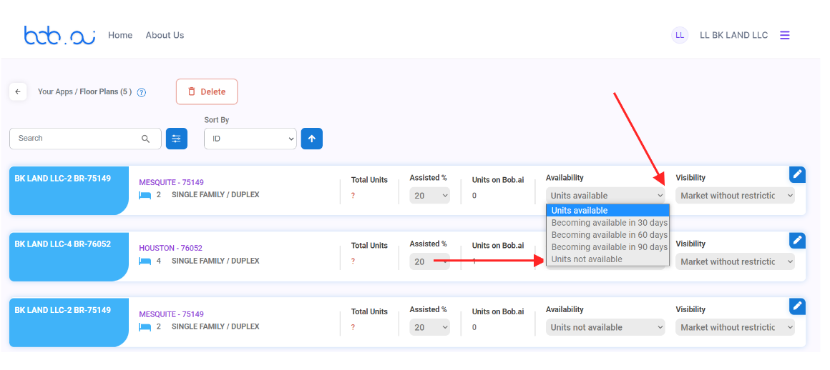

Unable to create an Account

Hello

Thanks for reaching out to Bob.ai support, we appreciate your patience as we work to improve our response time.

I'm sorry to hear that you have been having difficulty creating your account with Bob.ai

Please try these steps in an effort to resolve the issue.

1. Please try signing in from a different browser or an incognito chrome window Ctrl +shift +n

2. If that doesn't work please try creating the account by going to Bob.ai on your phone browser.

I hope this works, if you are still not able to create your account, respond to this email and let me know, please include screenshots of the issue displaying the full page.

Best Regards

App Issues

Hello

Thanks for reaching out to Bob.ai support, I'm happy to help!

I'm sorry that you are having trouble using the app. Please try restarting your device and then try to open the app again. If it still doesn't work please uninstall the app and then reinstall again from this link https://play.google.com/store/apps/details?id=com.bob.ai.

I hope this helps, however, if you still need help, please reply and let me know.

Best Regards

Upload Documents

Thanks for reaching out to Bob.ai support, we appreciate your patience as we work to improve our response time.

Before submitting the RFTA packet, you may upload any required documents by using the "Additional Documents" feature under manage RFTA.

I hope this helps, if you still have questions please let me know.

Best Regards

Expired Voucher

From a review of the records, we're seeing that your voucher has expired, hence why you are unable to sign the RFTA at this time. However, we have reached out to the DHA on your behalf requesting an extension.

We will send you an update as soon as we hear back.

Reset Account

You may reset your account by going to the My Account app on a computer and then clicking the reset button. After you have done the reset, you can sign back into the account using the same email and password combination.

If your landlord has already sent you a RFTA, you can find it under the "Manage RFTA" app.

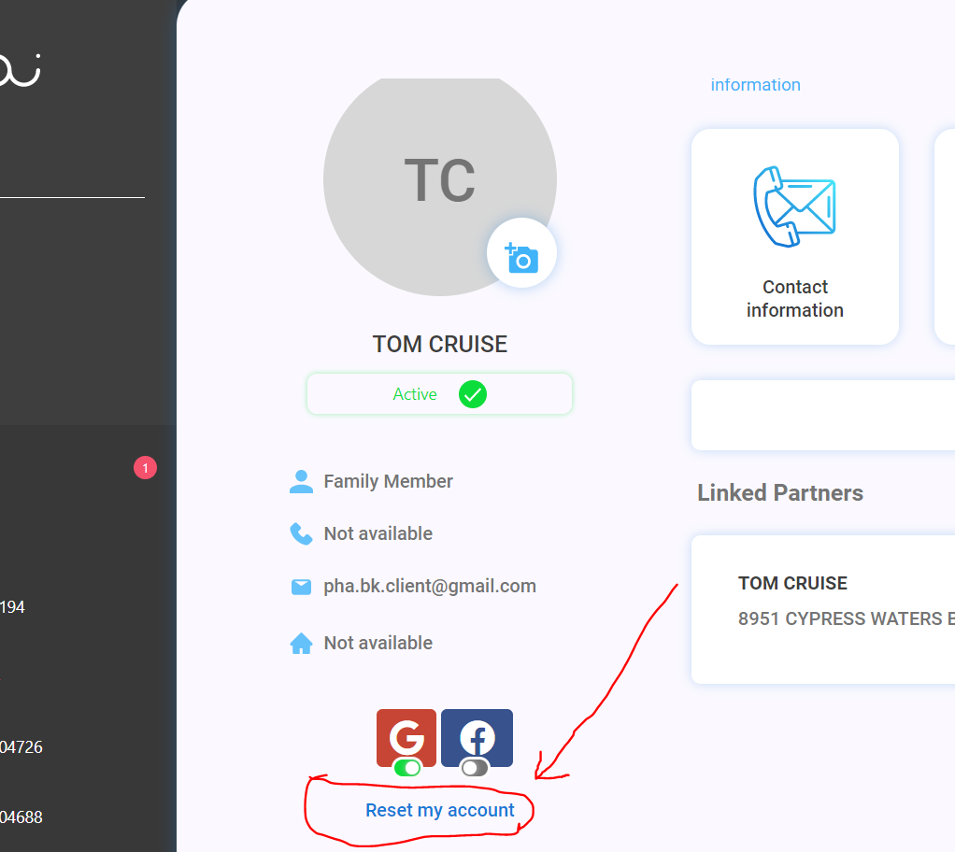

Hello Elisabeth

Thanks for contacting [Bob.ai](http://bob.ai/) support, we appreciate your patience as we work to improve our response time.

To fix this issue, kindly follow the steps below:

1. log into your [Bob.ai](http://bob.ai/) account

2. go to My Account

3. scroll down to the bottom of the page and click Reset Account

4. Log back into [Bob.ai](http://bob.ai/)

5. Go to My Account

6. Select Enter Relationship code

7. Select I do not see My Relationship code

8. Set up your account with your appropriate role

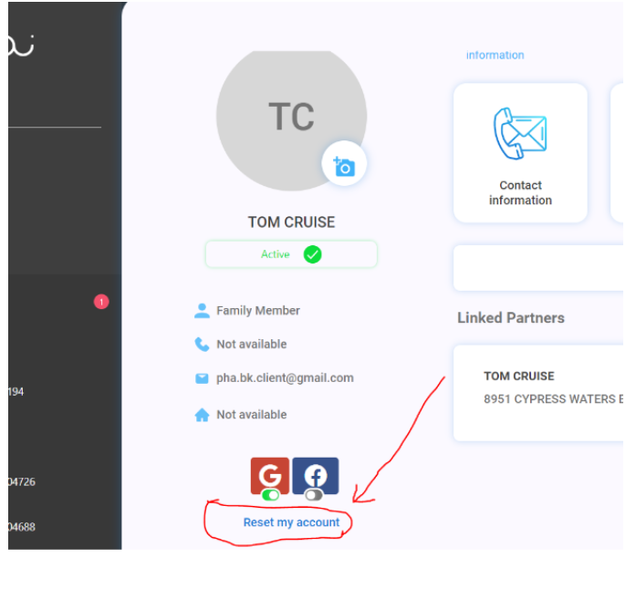

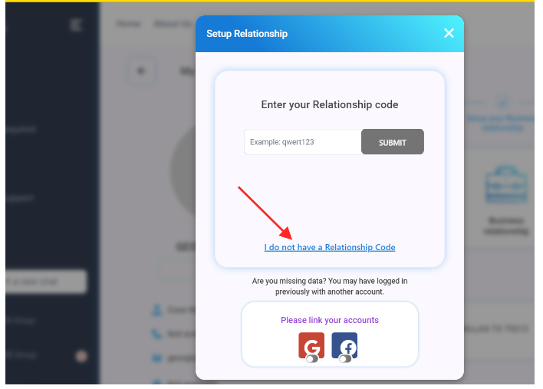

I hope this helps

Forgot Password

To reset your password, kindly click “Forgot Password” on the login page, then enter your email address. We’ll send a reset link to your email address and you can create a new password.

I hope this helps, however, please let me know if you are still having difficulty.

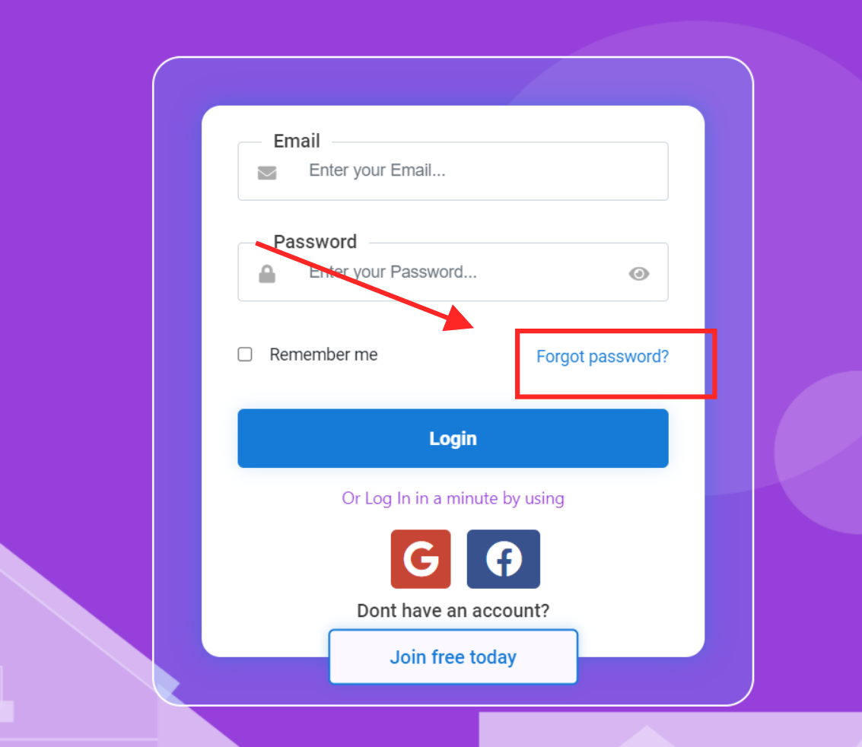

Units for my voucher

It can take a few hours for the units to show up, please give it some time and then check back. As long as your account was created with the email address that is on your voucher you should be set.

If a landlord has already sent a RFTA for you to sign, you should find it under the Manage RFTA app.

Thank you

More Details

Hello

Thanks for contacting Bob.ai support, we appreciate your patience as we work to improve our response time.

I'm happy to help! So that I can best assist you, kindly provide more details about the issue you are having. If possible please include screenshots as well.

Awaiting your response

****************************************************************************************

Hello,

Thanks for contacting [Bob.ai](http://bob.ai/) support, I'm happy to help!

Can you please elaborate which information you are not able to find out, So that we can help you respectively.

Please Feel free to contact us, We are always here to help you.

I hope this helps.

Additionally, you may visit Bob.ai-Youtube for other helpful guides.

Management Agreement

The management agreement is any document in your possession that shows that you are authorized to sign on behalf of the legal owner of the property.

Once a leasing agent or property manager is signing the RFTA on behalf of the owner, DHA requires the management agreement is included in the RFTA package.

You may go to Additional Documents, select Management Agreement from the drop down and then upload your file into the RFTA.

More Information

Hello

Thanks for contacting Bob.ai support, I'm sorry to hear that you are having trouble.

So I can best assist you, please reply with more details about the issue, if possible, include screenshots as well.

Awaiting your reply

Account Updated

Hello

Your account has been updated and the issue should be resolved now. Please log in and let me know if you have any other issues.

We appreciate your patience.

Thanks,

Community

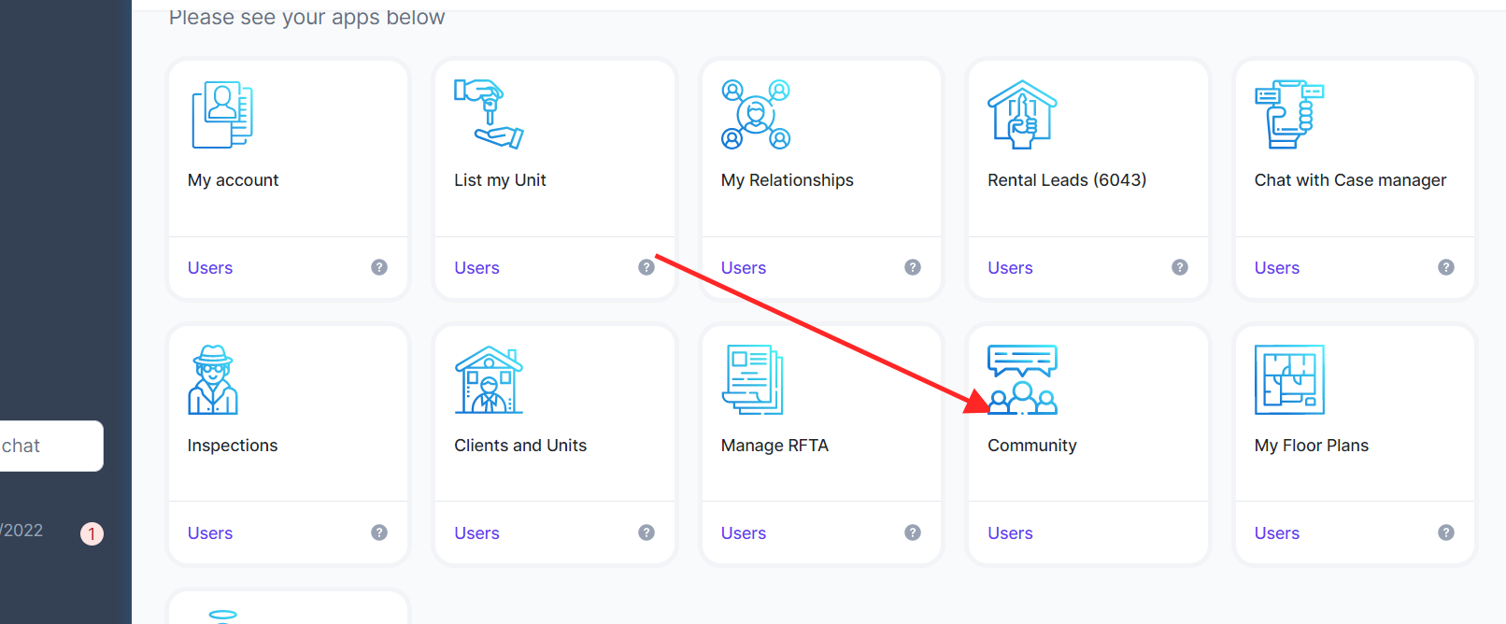

Rental Increase

Hello,

Thanks for contacting Bob.ai. We appreciate your patience as we work to improve our response times. Currently, we are not involved with that part of the process, but I did find these links on DHA's website, you may fill in and submit the form to them electronically.

[Landlord Reference Documents](https://dhantx.com/forms/request-for-rental-adjustment/)

[REQUEST FOR RENTAL ADJUSTMENT](https://dhantx.com/forms/request-for-rental-adjustment/)

"This form is required in order to process any upcoming rent increases for your DHA Housing Choice Voucher tenants.

Return the completed form to DHA at least 90 days prior to the end of the lease term; along with a copy of the notice of rent increase to your tenant. If approved, DHA will inform you of the effective date, to ensure that the tenant has 30 days’ notice of their increased rental portion."

I hope this helps.

Virtual Inspections

Hello

Thanks for contacting Bob.ai support, I'm happy to help.

To conduct your virtual inspection, you will need an outlet tester, a temperature gun, and a flashlight.

You should also have a smartphone. If you have an android phone the inspector will call you on Google duo, so please ensure the app is set up with the same phone number that is on your Bob.ai account.

If you have an iPhone the Inspector will call you on Facetime.

Thanks

Notice to Vacate

Hello

Thanks for contacting Bob.ai support, we appreciate your patience as we work to improve our response time.

You should be able to upload the Notice to Vacate from the Additional Documents section of the RFTA. You can also do this from the Bob.ai mobile app. https://youtu.be/uU3s1eCU8MQ

However, if you do not see this option please reply with a screenshot I'll be happy to assist further. Please note that there is no form to submit and you will need to draft this letter on your own and provide it to the landlord.

Thanks,

Your Bob.ai team

Missed Inspection

Inspectors typically reschedule missed/no-show inspections within 48hrs of the inspection date. If this is not done, please reach out to your housing authority directly to have them complete a reschedule.

Best regards

Voucher

As a renter, your voucher is linked to your Bob.ai account by your email address. You would only need to ensure that your Bob.ai account is created with the same email address that is on your voucher. If not, then you can create a new account using the correct email address.

Once you are signed in you should be able to see your voucher listed under Vouchers and Referrals. Then you can start looking for rentals under Units for my Voucher. If there are any units in our system that match your voucher, you may message the landlord for additional details on the unit and the next steps.

When a landlord sends you an RFTA for your signature, you can find it under Manage RFTA.

Please note you can also look for units outside of Bob.ai

I hope this helps.

Best regards

Update Contact Information

You may update your contact info in Bob.ai by going to My Account and then Contact Information.

You may add an additional email address, update your address and also correct your phone number. After making the changes ensure that you click Save, your changes will reflect throughout your account.

I hope this helps, if you have any other questions or concerns, please let me know.

Thanks

DHA Payment Inquiry

Thanks for contacting Bob.ai. We appreciate your patience as we work to improve response times. Unfortunately, we are not involved with the payment part of the process.

However, I've found this link on DHA’s website, where you can log in and check on your payment information there.

Hope this helps.

Your Bob.ai team

Schedule Inspection

Thank you for contacting Bob.ai. We appreciate your patience as we work to improve response times.

You can schedule an inspection by going to "Chat with a Case Manager" and creating a case. Under the Reason, select "HQS Inspections" and enter a detailed message for them regarding the type of request, date, client (if applicable), and unit address.

You will be assigned a caseworker from your housing authority who will be able to assist with your concern/inquiry. Response time is usually between 2-3 business days.

Self-certify Clients

Hi there,

To self-certify your inspection, you can follow these steps:

1. Log into your account,

2. Go to the Inspections app on the dashboard,

3. Click on the Action button on the far right of the inspection,

4. Choose Self-Certify.

Here's a [video](https://community.bob.ai/t/client-self-certification-re-inspection-guide/89) to show you how it is done on mobile as well.

Feel free to reach back out to us if you have any additional questions.

Take care,

Your Bob.ai team

I Dont See my Units   
  
Thanks for contacting Bob.ai support, we appreciate your patience as we work to improve our response time.

I'm happy to help and I've sent a relationship code to your email address. Kindly retrieve the code then go to Inspections. Click "I don't see my Inspection" then enter the relationship code where it is requested.

If you have any recent inspections for the missing units, they should turn up under Inspections. You should also now be able to see your units under Clients and Units.

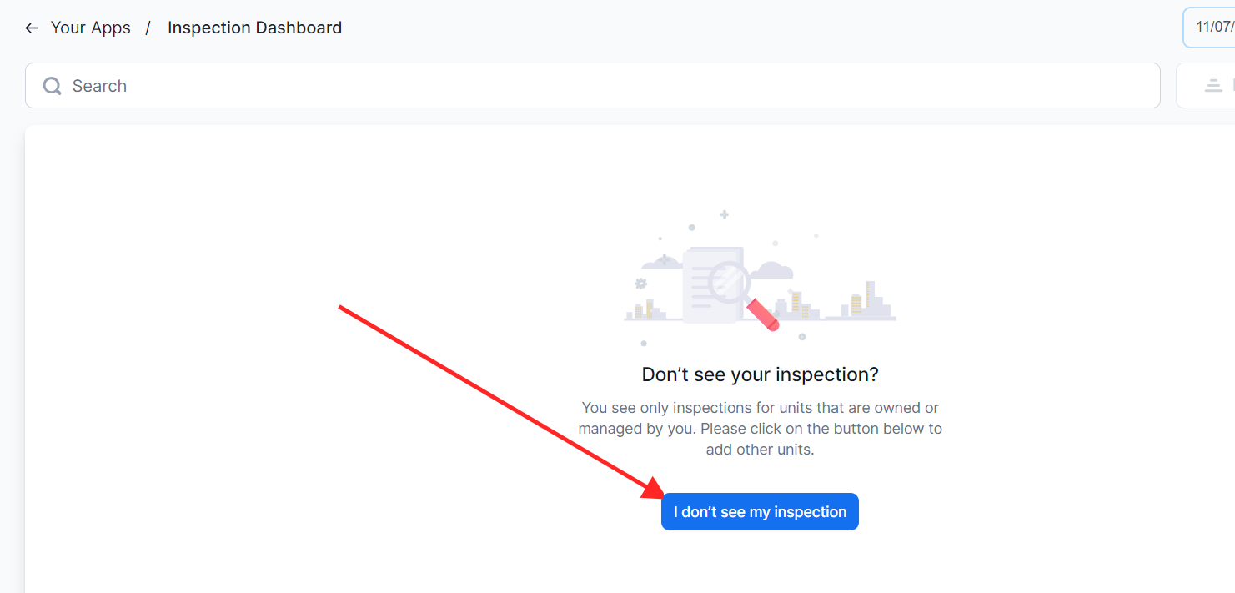

I hope this helps.

Feedback

We are extremely grateful that you took the time to send us your feedback about the feature. Your feedback helps us improve our product service for all users.

I read through your suggestions carefully, and consider them to be very insightful. I will pass them on to our product development team to see if they could implement any of these changes in the upcoming releases.

I do not see my Unit/adding units

Hello

Thanks for contacting Bob.ai support, we appreciate your patience as we work to improve our response time.

I'm happy to help! If you don't see a unit you own or manage under Inspections or Clients and Units, please select "I do not see my unit" and then follow the prompts to add it.

Here is a video to help you with this [Can't find my inspection - Housing Providers](https://www.youtube.com/watch?v=ja5oHPO0Vwc&t=53s)

I hope this helps, however, if you have more questions, please reply to this email.

Best wishes

Landlord Getting Started

Once you have found a renter for your unit you would only need to create an RFTA for them from the Manage RFTA tab on [Bob.ai](http://bob.ai/)

Then once the RFTA has been submitted to the housing authority and approved, your relationship with the will be set and you wil be an approved landlord.

I have attached a step-by-step guide that should be helpful, you may also check out Community for video guides and recordings from or landlord workshops.

I hope this helps

Rephrase

Thanks for contacting Bob.ai support. Although I'm happy to help, I'm not sure I understand your issue. Could you kindly rephrase it?

Please also provide any relevant screenshots of the problem.

How to void RFTA

Thanks for contacting [Bob.ai](http://bob.ai/) support, I'm happy to help!

If you want to Void the RFTA then please follow these steps-

1- Log in to [Bob.ai](http://bob.ai/)

2- Go to Manage RFTA app.

3- Open Your RFTA

4- Click Choose Actions

5- Under "Choose Actions" you will find the "Void" option.

6- Then click "Void"

7- Specify the reason for voiding.

8- Then click "Submit"

Refer to the screenshot-

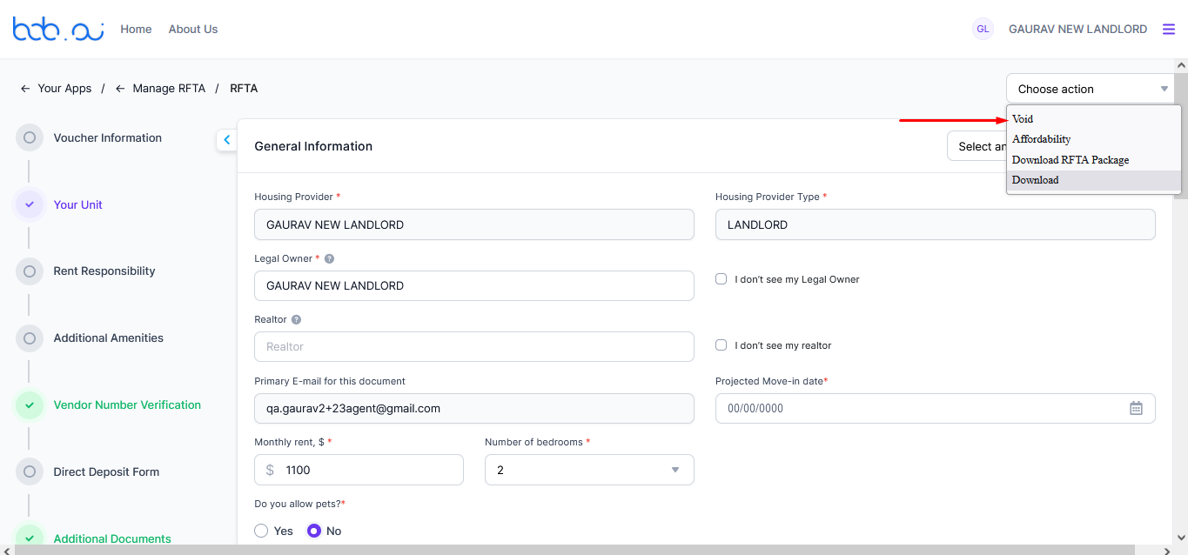

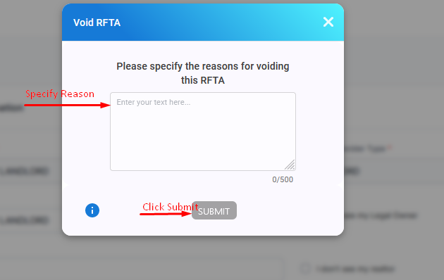

If the issue still persists then please feel free to contact us. We are always here to help you.

I hope this helps.

Update Email-How to

Hello,

Thanks for contacting [Bob.ai](http://bob.ai/) support, I'm happy to help!

If you want to update your Email on Bob then you need to send an invitation to your current/New Email.

For Invitation please follow these steps-

1- Log-in to [Bob.ai](http://bob.ai/)

2- Go to My Account.

3- Go to Users in my Account

4- Then click on Invite Member.

5- Invitation Pop-up will open.

6- In the Email field you can Enter your current/New Email that you want to update.

For any other help please feel free to contact us, We are always here to help you.

I hope this helps.

Additionally, you may visit Bob.ai-Youtube for other helpful guides.

Your [Bob.ai](http://bob.ai/) team

## 